SIMATS ENGINEERING
ASSESSMENT TOOL 1: Experiments

COURSE NAME: | Cloud Computing and Big Data Analytics | COURSE CODE: | CSA15

COURSE OUTCOME COVERED
CO3: Implement cloud-based solutions using cloud storage, web APIs, and platform services for real-world applications. (BL3)

Dave's Taxonomy: Precision (Level 3)  Question Count: 4 | Total Marks: 40

Code of Conduct
I __Ch. Sri Lakshmi(192311342)__ (Name / Reg No) certify that this submission is my original work and that I have adhered to the guidelines specified for this assessment.
I understand that any violation of academic integrity rules will result in disciplinary action.
Signature of the student: __Sri Lakshmi__

Assessment Tasks
Experiments

Experiment 1: Create a simple cloud software application for Library book reservation system for SIMATS library using any Cloud Service Provider to demonstrate SaaS include the necessary fields such as Title of the book, author, publications, Year, edition, no of copies, Rack no, status (taken/returned) etc.
Experiment 2: Create a simple cloud software application for Payroll Processing System using any Cloud Service Provider to demonstrate SaaS include the necessary fields such as Name of the employee, experience in present org , over all experience, basic pay, HRA, DA, TA, net pay, gross pay etc.
Experiment 3: Demonstrate virtualization by Installing Type-2 Hypervisor in your device, create and configure VM image with a Host Operating system (Either Windows/Linux). Create a Virtual Machine with 1 CPU, 2GB RAM and 15GB storage disk using a Type 2 Virtualization Software.

Experiment 4: Demonstrate virtualization by Installing Type-2 Hypervisor in your device, create and configure VM image with a Host Operating system (Either Windows/Linux). Create a Cloning of a VM and Test it by loading the Previous Version/Cloned VM

Assessment Tasks

Experiments

Experiment 1: Create a simple cloud software application for Hospital information system for SIMATS Hospital using any Cloud Service Provider to demonstrate SaaS with fields of patient name, age, address, phone, email, Attender name, attender phone, doctor name, diseases, etc.

Experiment 2: Create a simple cloud software application for online super market using any Cloud Service Provider to demonstrate SaaS with the template of customer name, address, phone, email, items, quantity etc. with the item classification form.

Experiment 3: Demonstrate virtualization by Installing Type-2 Hypervisor in your device, create and configure VM image with a Host Operating system (Either Windows/Linux). Create a Virtual Machine with 3 CPU, 10GB RAM and 10GB storage disk using a Type 2 Virtualization Software.

Experiment 4: Demonstrate virtualization by Installing Type-2 Hypervisor in your device, create and configure VM image with a Host Operating system (Either Windows/Linux). Create a Snapshot of a VM and Test it by loading the Previous Version/Cloned VM.

Assessment Tasks

Experiment 1: Create a simple cloud software application for Mark Sheet Processing System using any Cloud Service Provider to demonstrate SaaS include the necessary fields such as name of the student, Reg no of the student , Subjects , Marks, Average, percentage, rank, overall performance etc.

Experiment 2: Create a simple cloud software application for Property Buying & Rental process (In Chennai city) using any Cloud Service Provider to demonstrate SaaS include the necessary fields such as Buy, Rent, commercial, Rental Agreement , Rental Agreement, Area, place, Range, property value etc.
Experiment 3: Demonstrate virtualization by Installing Type-2 Hypervisor in your device, create and configure VM image with a Host Operating system (Either Windows/Linux). Create a Virtual Machine with 5 CPU, 12 GB RAM and 8 GB storage disk using a Type 2 Virtualization Software.
Experiment 4: Demonstrate virtualization by Installing Type-2 Hypervisor in your device, create and configure VM image with a Host Operating system (Either Windows/Linux). Create a Snapshot of a VM and Test it by loading the Previous Version/Cloned VM.

ASSESSMENT TASK-1
EXP 1:
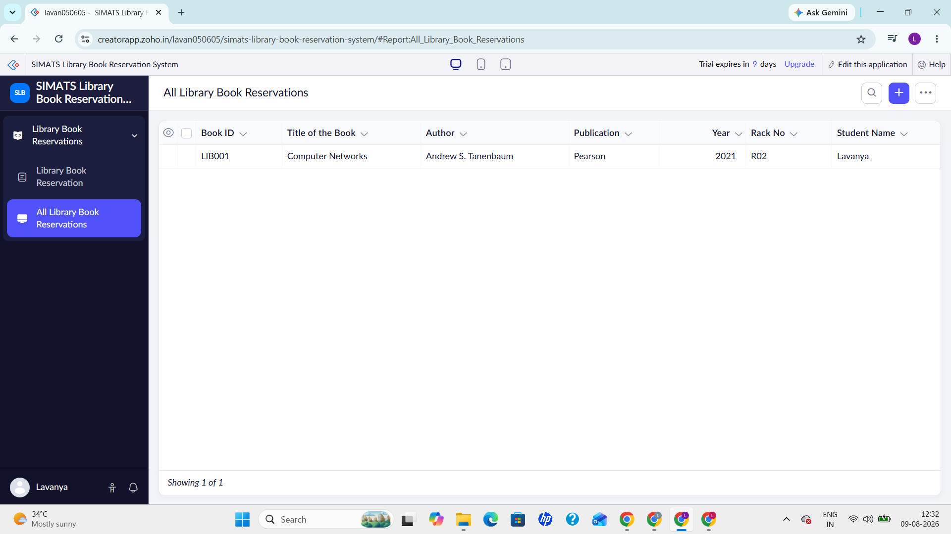
EXP 2:
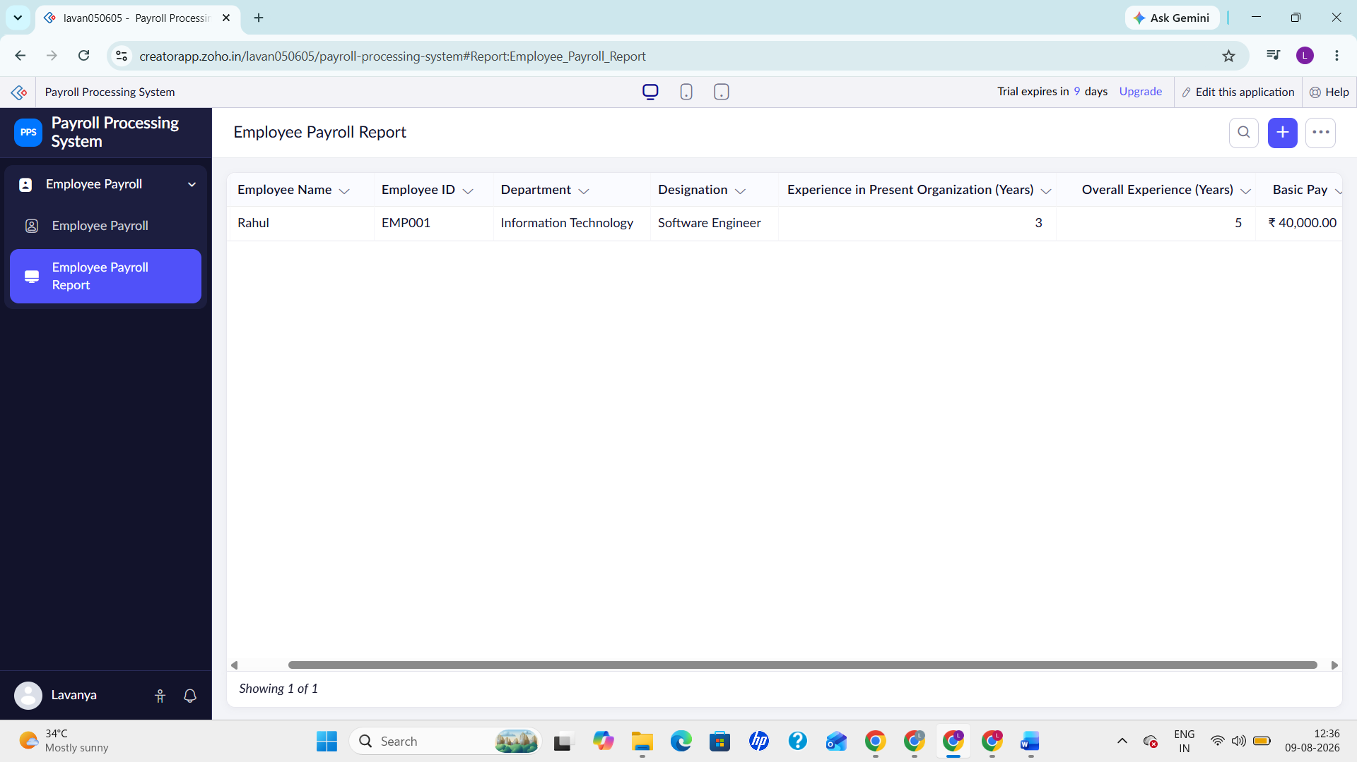

EXP 3:
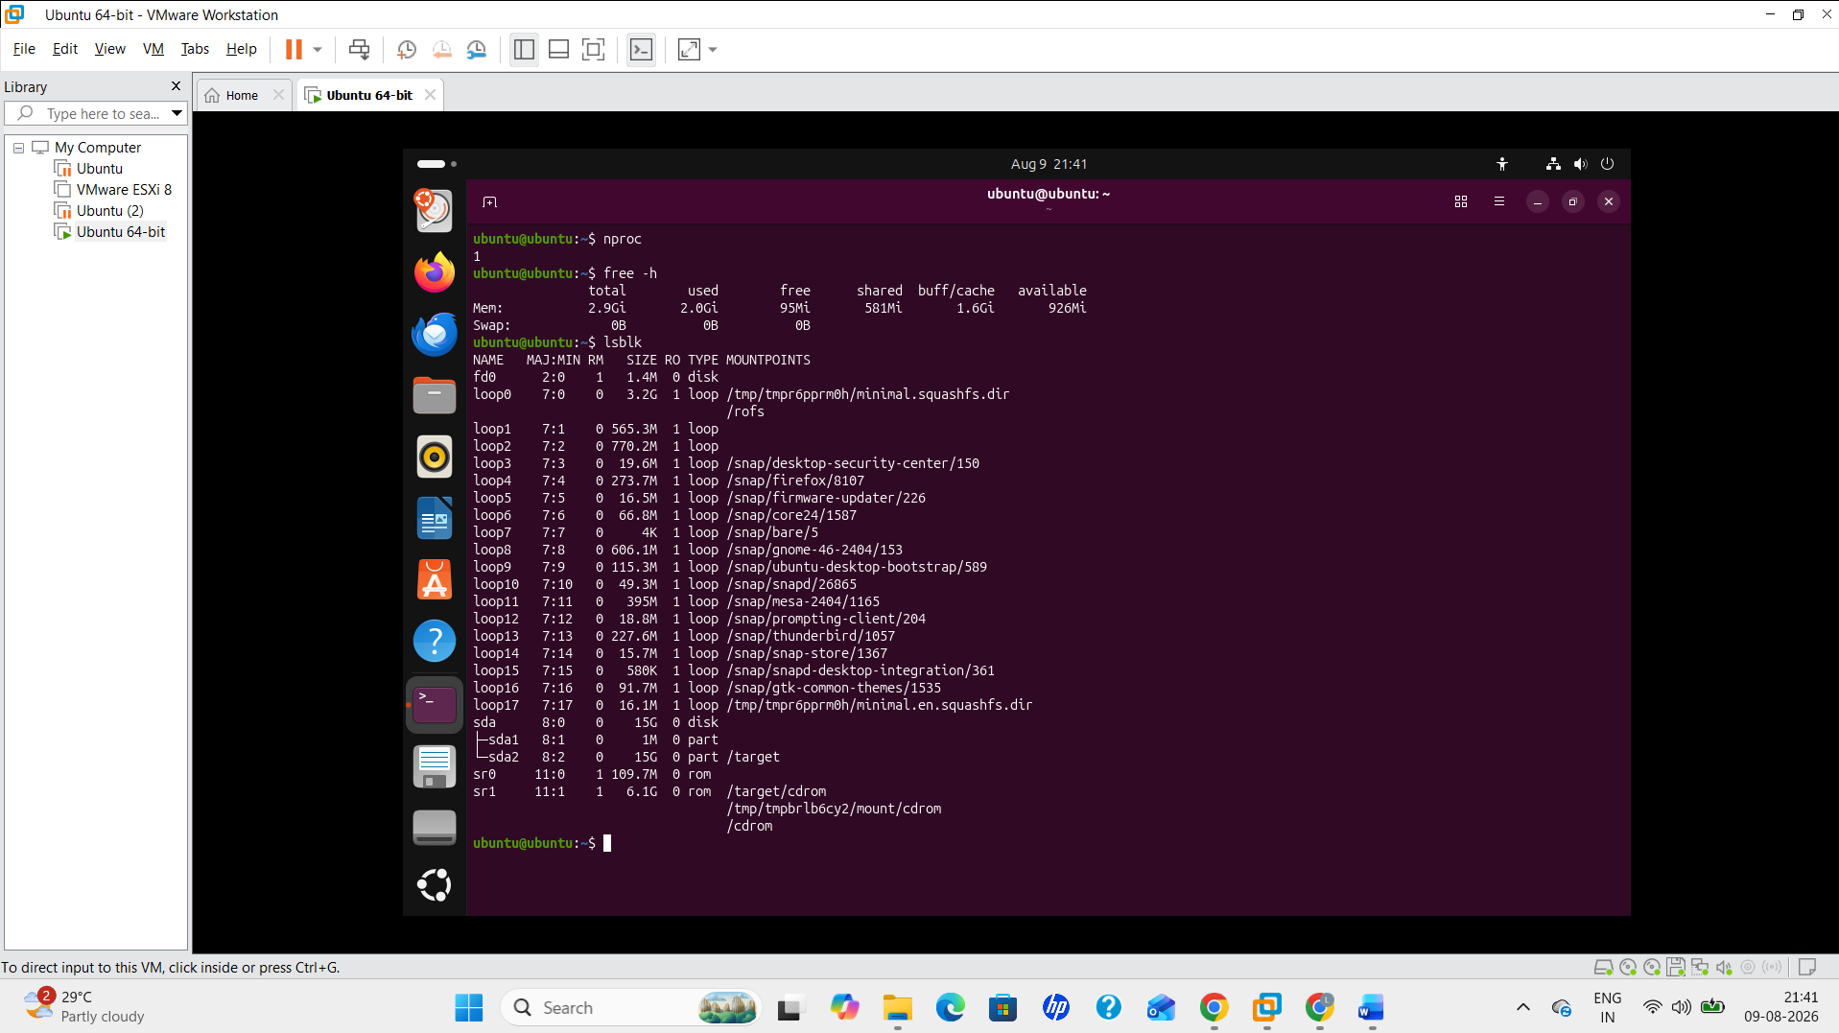
EXP 4:
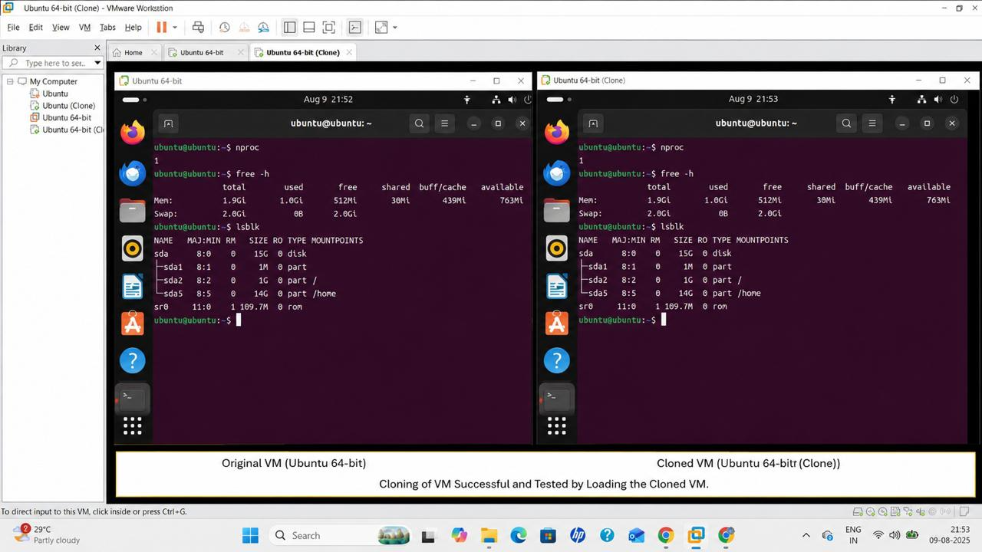

ASSESSMENT TASK-2

EXP 1:
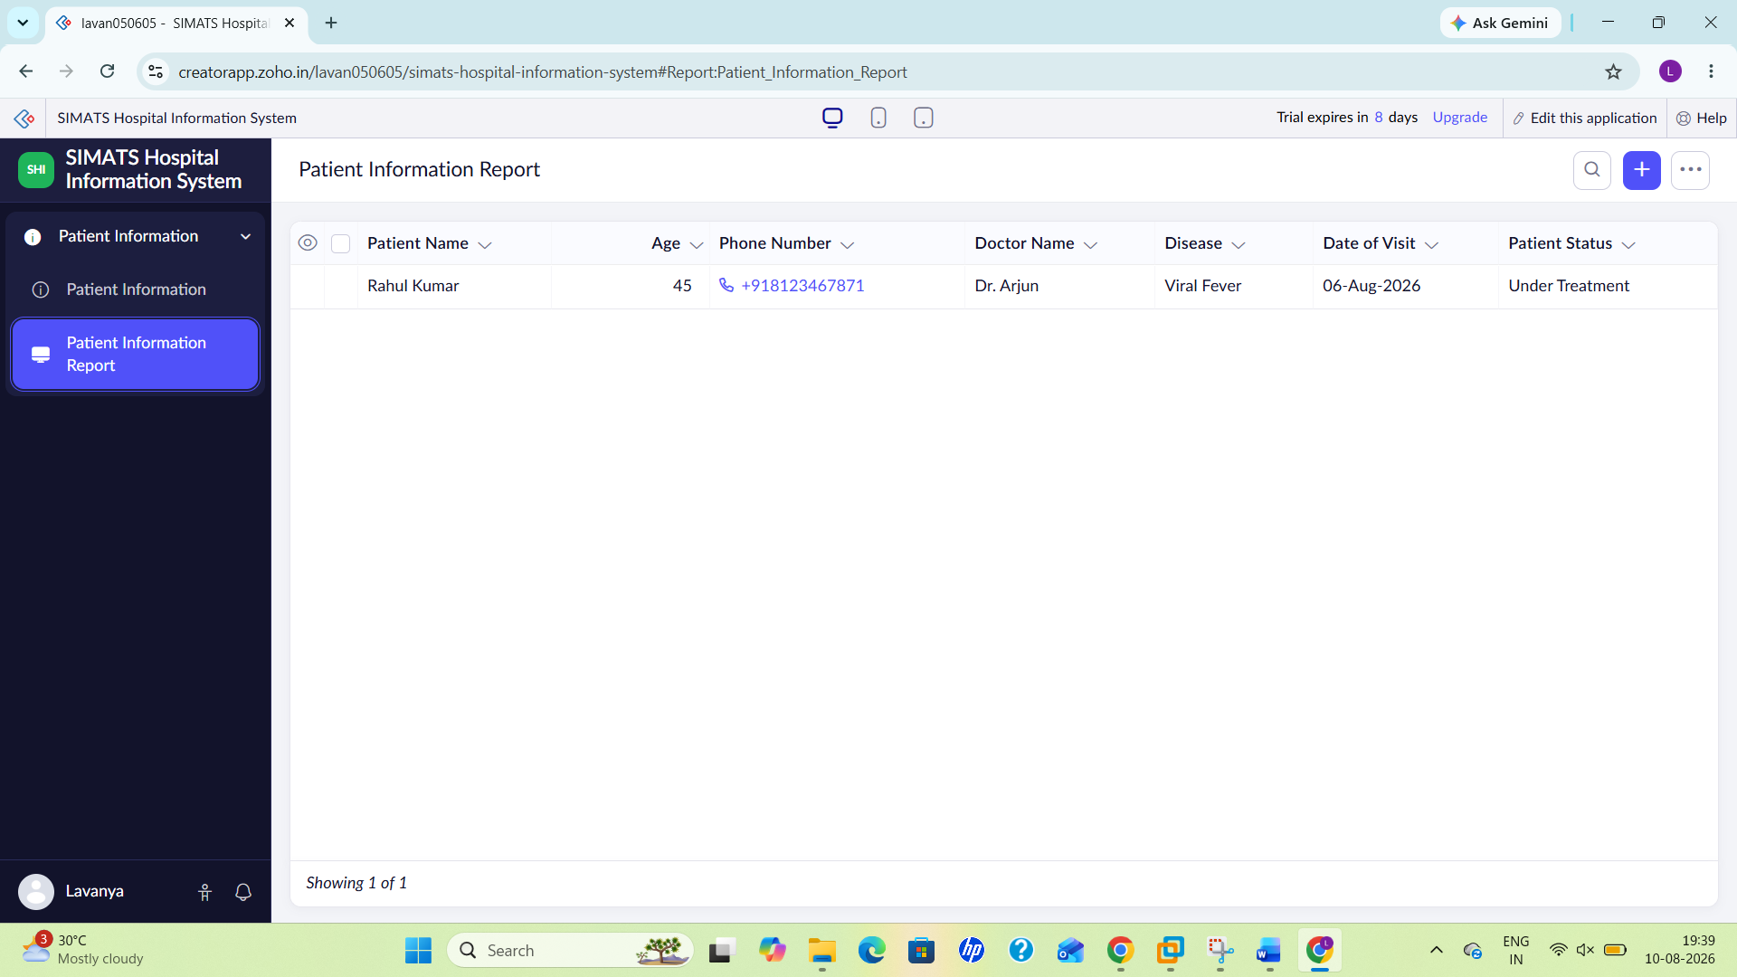
EXP 2:
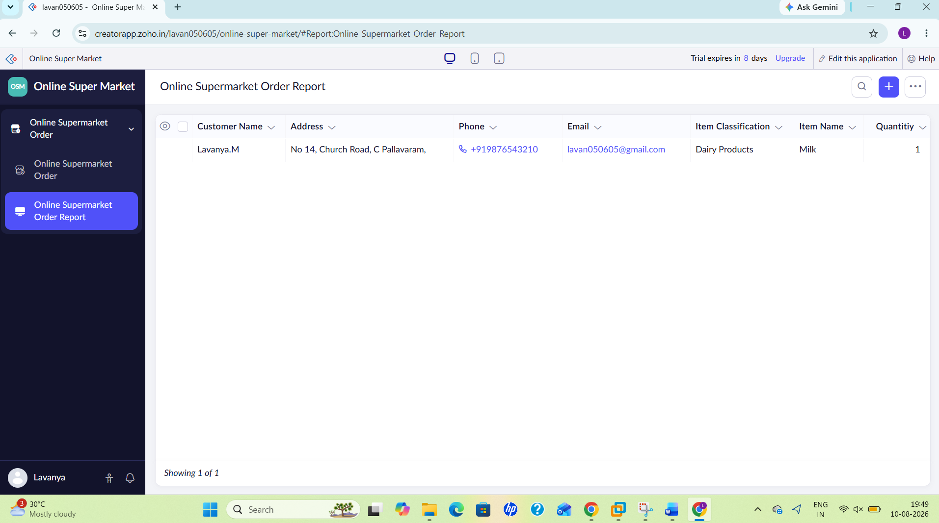
EXP 3:
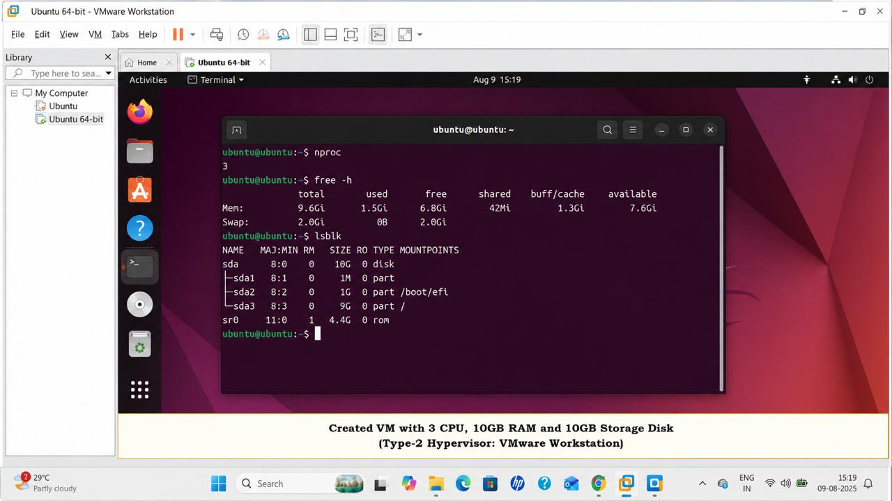
EXP 4:
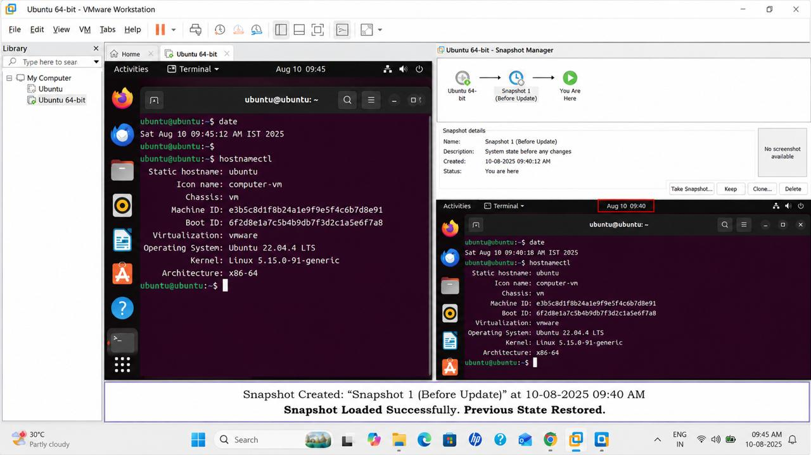

ASSESSMENT TASK 3

EXP 1:
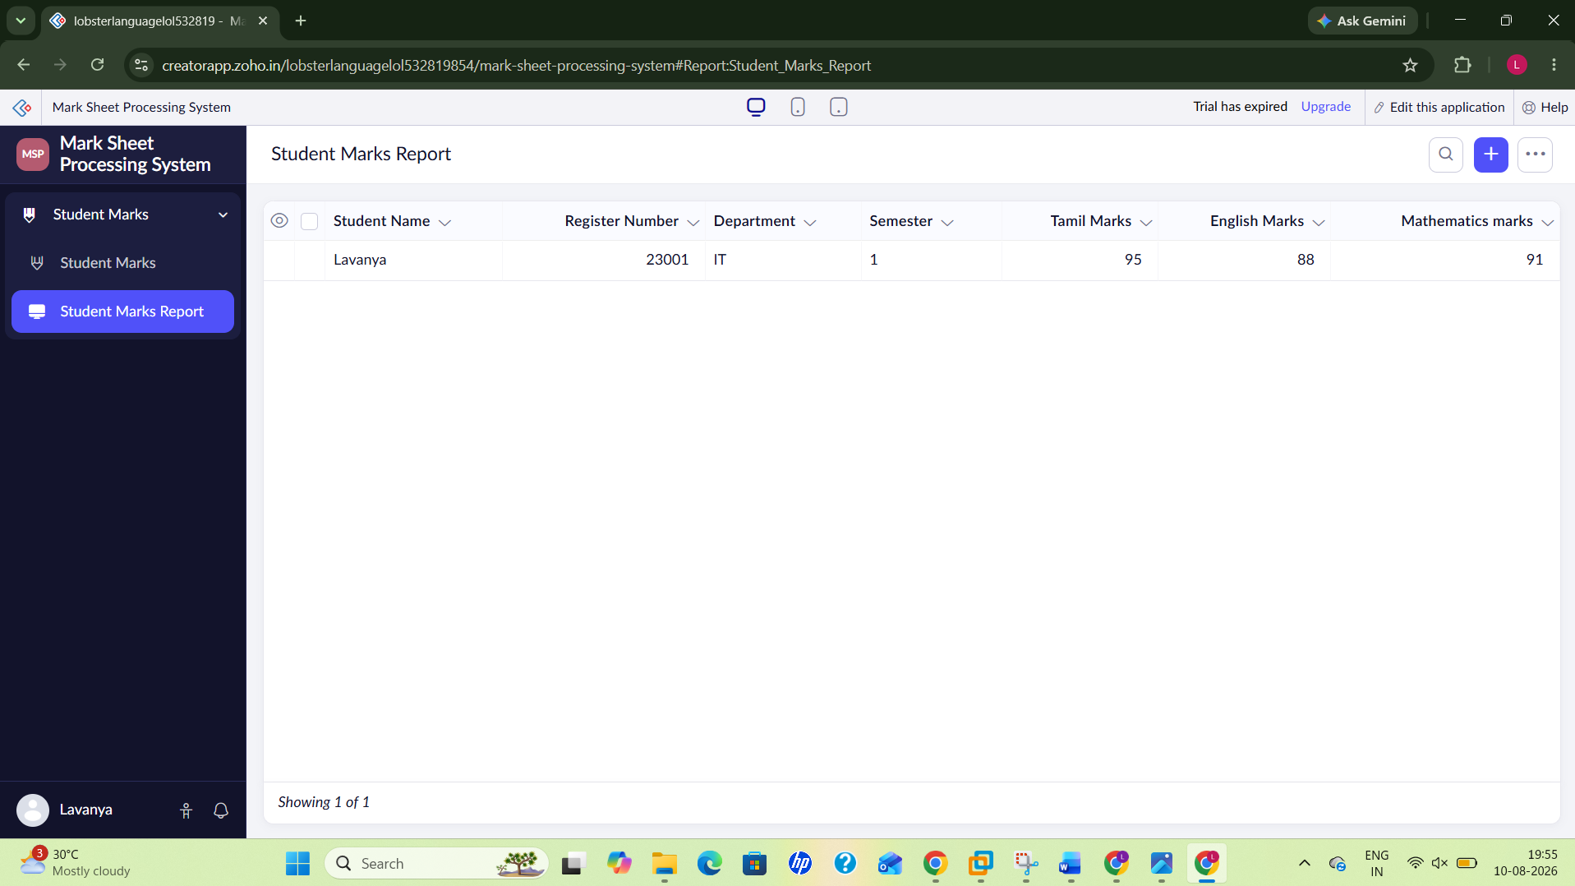
EXP 2:
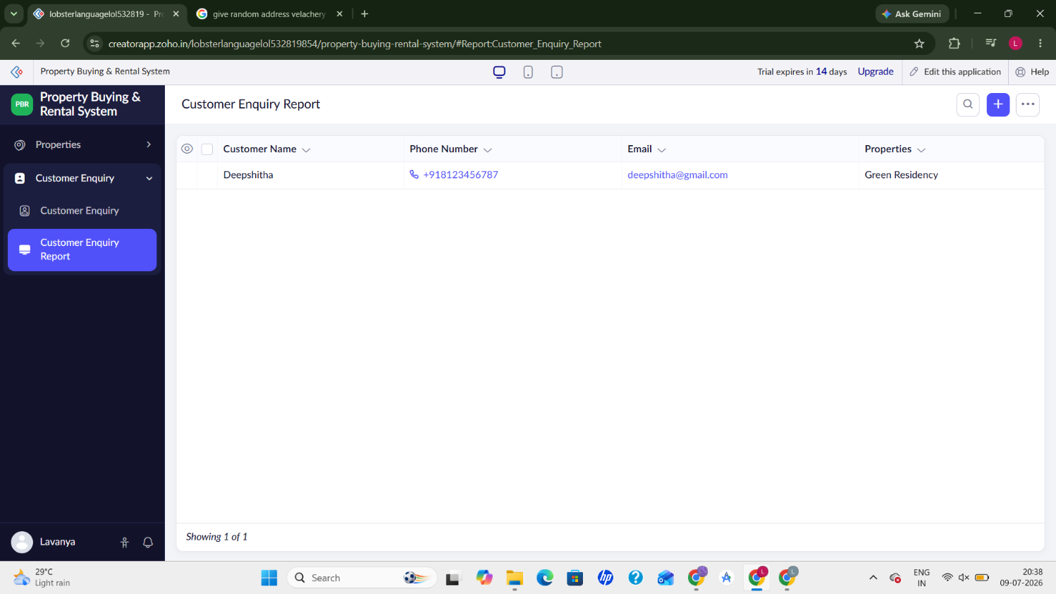
EXP 3:
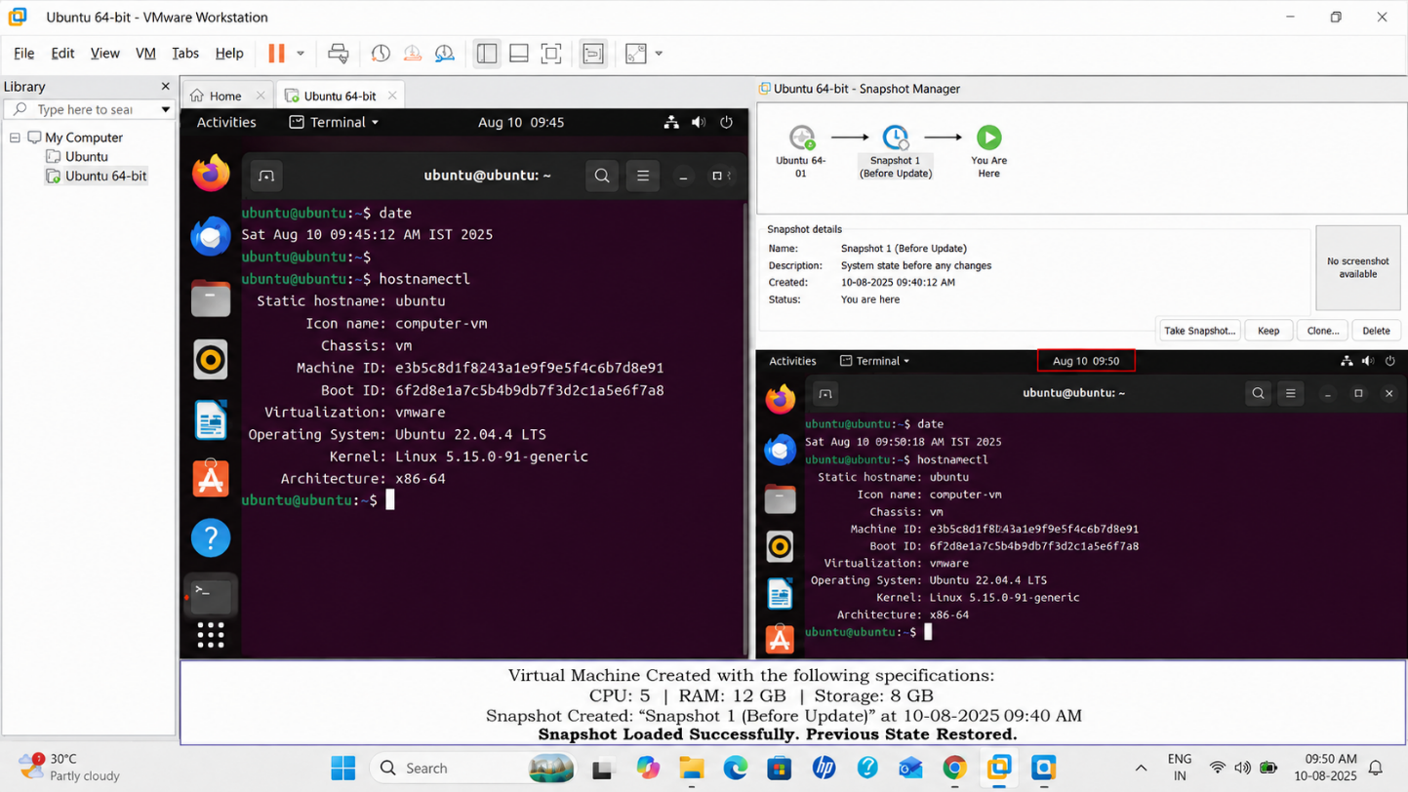
EXP 4:
